��<�span jsslot=""><�div class="n3x5Fb" aria-hidden="true"><�svg aria-hidden="true" class="stUf5b" fill="currentColor" focusable="false" width="24px" height="24px" viewBox="0 0 24 24" xmlns="https://www.w3.org/2000/svg"><�path d="M7 11v2h10v-2H7zm5-9C6.48 2 2 6.48 2 12s4.48 10 10 10 10-4.48 10-10S17.52 2 12 2zm0 18c-4.41 0-8-3.59-8-8s3.59-8 8-8 8 3.59 8 8-3.59 8-8 8z"><�/path><�/svg><�/div><�/span>

Activities Terminal

Mon 14:23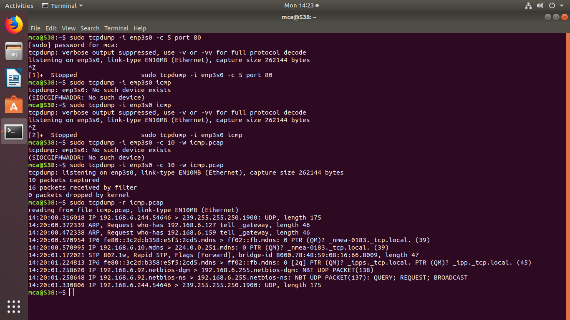

mca@S38: File Edit View Search Terminal Help mca@s38:~$ sudo tcpdump -i enp3s0 - 5 port 80 [sudo] password for mca: tcpdump: verbose output suppressed, use -vor -vv for full protocol decode listening on enp3so, link-type EN10MB (Ethernet), capture size 262144 bytes AZ [1]+ Stopped

sudo tcpdump -i enp3s0 - 5 port 80 mca@s38:$ sudo tcpdump -i emp3s0 icmp tcpdump: emp3s0: No such device exists (SIOCGIFHWADDR: No such device) mca@s38:~$ sudo tcpdump -i enp3so icmp tcpdump: verbose output suppressed, use -V or -vv for full protocol decode listening on enp3so, link-type EN10MB (Ethernet), capture size 262144 bytes AZ [2]+ Stopped

**sudo tcpdump -i enp3so icmp nca@s38:-$ sudo tcpdump -i emp3s0 - 10 -W icmp.pcap tcpdump: emp3so: No such device exists (SIOCGIFHWADDR: No such device) mca@s38:-$ sudo tcpdump -i enp3s0 - 10 -W icmp.pcap tcpdump: listening on enp3so, link-type EN10MB (Ethernet), capture size 262144 bytes 10 packets captured 16 packets received by filter O packets dropped by kernel imca@s38:~$ sudo tcpdump -r icmp.pcap reading from file icmp.pcap, link-type EN10MB (Ethernet) 14:20:00.316018 IP 192.168.6.244.54646 > 239.255.255.250.1900: UDP, length 175 14:20:00.372339 ARP, Request who-has 192.168.6.127 tell gateway, length 46 14:20:00.472338 ARP, Request who-has 192.168.6.159 tell gateway, length 46 14:20:00.570954 IP6 fe80::3c2d:b358:e5f5:2cd5.mdns > ff02:: fb.mdns: OPTR (OM)? _nmea-0183. tcp.local. (39) 14:20:00.570995 IP 192.168.6.10.mdns > 224.0.0.251.mdns: O PIR (OM)? _nmea-0183. tcp.local. (39) 14:20:01. 172021 STP 802.1w, Rapid STP, Flags [Forward), bridge-id 8000.78:48:59:08:16:66.8009, length 47 14:20:01.224813 IP6 fe80::3c2d:b358:e5f5:2cd5.mdns > ff02::fb.mdns: 0 [29] PTR (QM)? _ipps. tcp.local. PTR (OM)? ipp._tcp.local. (45) 14:20:01.258620 IP 192.168.6.92.netbios-dgm > 192.168.6.255.netbios-dgm: NBT UDP PACKET(138) 14:20:01.258648 IP 192.168.6.92.netbios-ns > 192.168.6.255.netbios-ns: NBT UDP PACKET(137): QUERY; REQUEST; BROADCAST 14:20:01.330806 IP 192.168.6.244.54646 > 239.255.255.250.1900: UDP, length 175 mca@s38:~$ 0**